ANALYTICS REPORTS IN vUWS

The information in this document has been amended from BlackBoard Learn 9 Help features, available within the specific report sections.
V.1 July 2019

Contents
Navigating vUWS Analytics Reports 2
Overview of Reports 3
Unit at a glance report 4
Activity & Grade Scatter Plot report 7
Activity and Grade Matrix Report 9
Course Submission Summary Report 11
Course Reports 12
Performance Dashboard 13
Retention Centre 14

Navigating vUWS Analytics Reports
The Evaluation section of the “Course Management” tool in vUWS contain many reports that may be useful throughout semester.
This section can be accessed on the left hand menu of the vUWS site under the section
Course Management > Evaluation

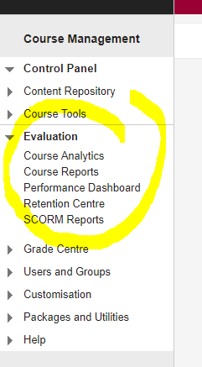
Note: BlackBoard uses the term Unit where Western Sydney University use the term unit. These two terms are used interchangeably throughout BlackBoard and this document.

Overview of Reports
Reports | Report Description
Unit Analytics
Unit at a glance | Compares this unit against other units in the same school.
Activity and Grade Scatter Plot | Plots the distribution of student activity against their grades in this unit.
Activity Matrix | Shows a visual representation of student activity in the unit.
Unit Submission Summary | Summary of user submissions for the unit.
Unit Reports
All User Activity inside Content Areas | This report displays a summary of all user activity inside Content Areas for the subject.
Overall Summary of User Activity | The report displays user activity for all areas of the subject, as well as activity dates, times and days of the week.
Single Subject User Participation Report | Displays detailed statistics on assessment and collaboration tool submissions for all users in this subject during a specified timeframe.
Student Overview for Single Subject | Student Overview for Single Subject displays an individual student's activity within a subject, sorted by date. Data includes the total overall time the student spent in the subject as well as detailed information about the student's activity, such as which items and Content Areas the student accessed and the time spent on each.
Subject Activity Overview | Subject Activity Overview displays overall activity within a single subject, sorted by student and date. Data includes the total and average time spent per active student and the total amount and type of activity each student had in the subject. Optionally, you can filter the report by one or more groups.
Subject Performance | This report displays information showing how a single Blackboard Learn Subject performs against a selected set of goals. Performance targets and a range of acceptable performance for the subject can be determined when running the report. Data includes averages for the entire subject as well as break downs for individual students and goals.
User Activity in Forums | This report displays a summary of user activity in Discussion Board Forums for the subject.
User Activity in Groups | This report displays a summary of user activity in Groups for the subject.
Performance Dashboard
The Performance Dashboard provides an up-to-date report on the activity for all students. Information appears in a table format.
Retention Centre
The Retention Centre provides an easy way for you to discover which students in your unit are at risk, determined by a set of criteria.
SCORM Reports
SCORM Reports can gather selected users' total time spent, status and result of a SCORM package. This will only be available where SCORM packages are used.

Unit at a glance report
Unit at a glance compares this unit against other units in the same school.
This report is useful for comparing the activity in a unit and the amount of content to the school average.
About this Report
This report provides summary information about one Blackboard Learn unit, and comparative information against a group of other Blackboard Learn units in the same academic department.
This report can help analyse how a particular unit is designed, how the unit compares to the average of other Learn units in the same department, and how the students in the unit are using and performing in the unit compared to the average of all students enrolled in the Learn unit.
Using the Report
After the report has been run successfully, the unit’s activity can be compared to the department average in several ways. The students enrolled in the unit can also be compared to the Learn Unit average.
The Learn Unit Information section presents general information about the selected unit.
The Department Avg sections displays several line charts of the selected Learn Unit compared to the average of the other Learn unit in the same department during the same term. The following measures are displayed:
- Unit Accesses Avg. vs. Department Avg: The average number of times the enrolled students accessed the Learn unit during the selected term, compared to the department average per unit for the same term.
- Minutes Avg. vs. Department Avg: The average amount of time (in minutes) the enrolled students spent in the Learn Unit during the selected term, compared to the department average per unit for the same term.
- Interaction Avg. vs. Department Avg: The average number of actions the enrolled students initiated in the context of the Learn Unit during the selected term, compared to the department average per unit for the same term. Many types of student actions can lead to an interaction being logged, such as accessing a unit item, submitting a discussion forum post, etc.
- Submission Avg. vs. Department Avg: The average number of Assignment, Blog, Discussion, Journal, Safe Assignment, Survey, and Test submissions made by the enrolled students during the selected term, compared to the department average per unit for the same term.
The Unit Item Count vs. Department Avg section displays unit item measures for the selected Learn Unit compared to the selected comparison group.
- Item Count (Assessment): The count of assessments (e.g. tests, assignments, etc.) in the selected Learn Unit compared to department average per unit.
- Item Count (Content): The count of content items (e.g. pages, documents, etc.) in the selected Learn Unit compared to the department average per unit.
- Item Count (Tool): The count of tools (e.g. discussion forums, blogs, journals, etc.) in the selected Learn Unit compared to the department average per unit.
The Avg. Activity per Student vs. Department Avg section displays activity measures for the selected Learn Unit compared to the selected comparison group.
- Activity (Accesses): The average unit accesses per student for the entire term in the selected Learn Unit compared to the department average per unit.
- Activity (Minutes): The average amount of time per student for the entire term in the selected Learn Unit compared to the department average per unit.
- Activity (Interactions): The average interactions per student for the entire term in the selected Learn Unit compared to the department average per unit. Many types of student actions can lead to an interaction being logged, such as accessing a unit item, submitting a discussion forum post, etc.
- Activity (Submissions): The average number of Assignment, Blog, Discussion, Journal, Safe Assignment, Survey, and Test submissions per student for the entire term in the selected Learn Unit compared to the department average per unit.
The Student Activity Summary section displays the enabled students enrolled in the selected Learn Unit along with several measures, comparing a given student against the average of other students enrolled in the same unit.
The following icons are conditionally displayed for all measures:
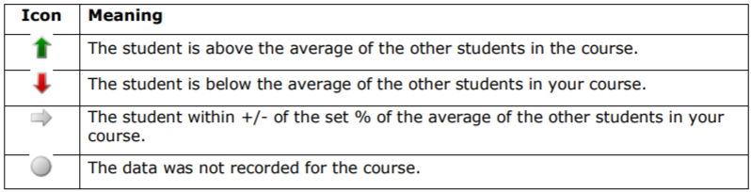
- Student: The student name, including the Student ID number. This column is sortable.
- Unit Access Trend: These trend lines show a given student’s unit accesses over the entire term.
- Unit Accesses: The number of times the selected student accessed the units in which she is enrolled during the selected term, compared to the average number of unit accesses for the other enrolled students for the same unit. This column is sortable.
- Minutes: The total amount of time (in minutes) that a given student has spent in the Learn Unit compared to the average time spent by all of the other students enrolled in the same unit. This column is sortable.
- Interactions: The total number of interactions for a given student in the Learn Unit compared to the average interactions by the other students enrolled in the same unit.
- Submissions: The total number of submissions for a given student in the Learn Unit compared to the average interactions by the other students enrolled in the same unit.
- Grade Centre Score: The student’s grade centre score (which uses the Grade Centre External Grade column), compared to the average of the other students enrolled in the same unit, both of which are established by the instructor. It is important to consider that the Grade Centre Score is determined by the instructor based on the way in which he or she has configured the Grade Centre, which may not necessarily correspond to the students’ official grade(s) of record, or the SIS grade.
- SIS Grade: The student’s grade (in points) from the SIS, compared to the average grade of the other students enrolled in the same unit.
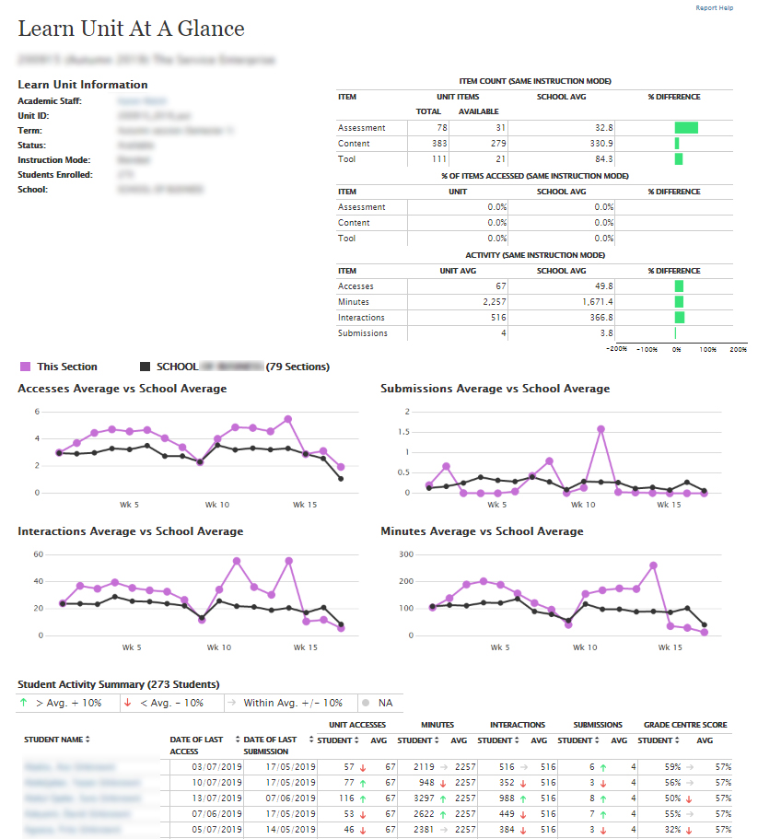

Activity & Grade Scatter Plot report
Activity and Grade Scatter Plot plots the distribution of student activity against their grades in this unit.
About this Report
This report plots students enrolled in a Learn unit against two variables: the Grade Centre External Grade and Unit Accesses. This report can help analyze how the activity of students does (or doesn’t) relate to the grade recorded in the Grade Centre.
The Grade Centre External Grade is a flag that can be set by an instructor in a Unit. By default, the Total column in the Grade Centre is set to be the External Grade, as shown below. The external grade flag can be changed to any Grade Centre column; this can be useful if an instructor wants to create a new column from which the student’s total score will be calculated. For more information about the External Grade flag, refer to the help documentation available in Blackboard Learn.
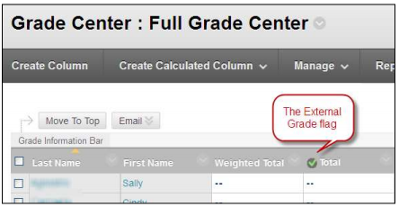
Typically the data that generates this report will be refreshed once a day. (The frequency with which data is refreshed is determined by your institution.) This means that if the external grade flag is changed, it will typically take until the next day for the change to take effect in this report. This is also true of student interactions, which will be approximately 1 day behind what has occurred in the Learn unit.
A student access is logged based on an action initiated by a student in the context of accessing a Learn Unit by logging in. As such, it is a general measure of activity in a Learn unit.
Using the Report
After the report has been run successfully, a plot of students enrolled in the unit is displayed against two variables: the Grade Centre External Grade and Unit Accesses.
Each point on the resulting report is a student enrolled in the unit. Moving the cursor over a dot will reveal the respective student’s name and student ID.
A linear regression line is included in the report. You can use this line to more easily determine if there is a positive or negative correlation between the Grade Centre grade and student unit accesses.
By moving the cursor over a point on the report, the student’s name is displayed. Only students who are set to “enabled” in the unit are displayed.
The report can be printed or exported using the icons at the top of the page.
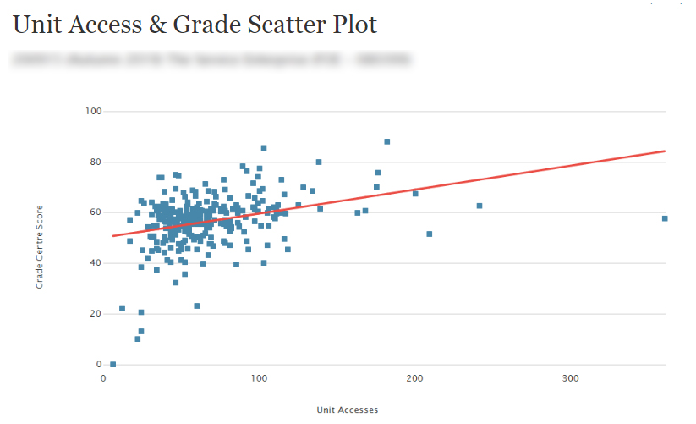

Activity and Grade Matrix Report
This report displays grade centre and interaction data on a relative basis for students enrolled in a Learn unit.
About this Report
The data is displayed for each student in aggregate, and over time, for the respective term. The relative comparison between students enrolled in the Learn unit is accomplished using statistical deciles, which divide the activity and grade data into 10 equal parts, the results of which are displayed graphically using a heat map colour scheme. Students are also assigned a “matrix” classification based on their relative activity and grade decile values, which provides a generalization of a student’s activity and grade profile in a unit.
This report can help analyze activity and grade patterns in a unit, and help find students with different usage and performance profiles, both of which can be used to support differentiated educational approaches.
The Learn grade centre grade used in this report is based on the column in the grade centre that is marked with the external grade flag. The Grade Centre External Grade is a flag that can be set by an instructor user in a Learn Unit. By default, the Total column in the Grade Centre is set to be the External Grade, as shown below. For more information about the External Grade flag, refer to the help documentation available in Blackboard Learn.
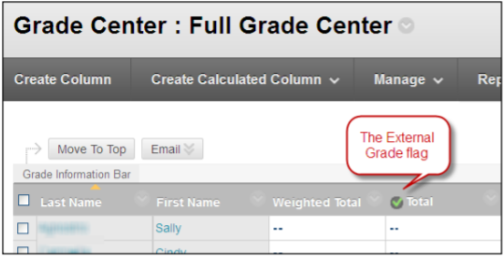
Using the Report
This report displays a grid of students enrolled in the unit and various decile and heat map information are displayed against two variables: the Grade Centre External Grade and the Interactions selected.
The decile values for the Activity and Grade for a given student are from 1-10. Each of these values is assigned a heat map colour, from blue (highest, or 1st decile) to red (lowest, or 10th decile).
- Student: The name of the student, including the student ID from the institution’s student information system. The name is displayed as a link, which goes to the Student At A Glance report. This column can be sorted by clicking on the column header.
- Interactions: The interactions decile value for a given student (1-10) displayed as a heat map. Moving the cursor over a given student’s decile heat map will display the decile value and the measure details. This column can be sorted by clicking on the column header.
- Grade: The Grade Centre External Grade decile value for a given student (1-10) displayed as a heat map. Moving the cursor over a given student’s decile heat map will display the decile value and the measure details. This column can be sorted by clicking on the column header.
- Matrix: The Activity & Grade Matrix value for a given student, displayed as an icon corresponding to the classification. Moving the cursor over a given student’s matrix category will display the category classification, and the activity and grade deciles. Clicking on a student’s icon will drill down to a more detailed matrix view. This column can be sorted by clicking on the column header.
Each student is assigned a matrix category as follows:
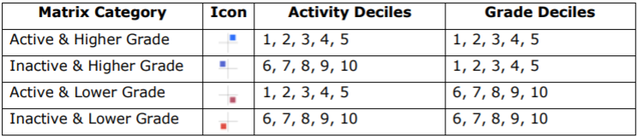
- Activity by Week of Term: The decile value for a given student (1-10) displayed as a heat map, by the week of the respective term. Moving the cursor over a given student’s decile heat map will display the decile value and the measure details.
This report might be useful to find students who fit certain activity and performance profiles, which can then be used to inform a differentiated educational approach. For example, by sorting on the matrix column, students are sorted into the four matrix categories described above. This makes it easy for instructors to find students that, for example, are very active in a Learn unit, but who are struggling from a grade perspective.
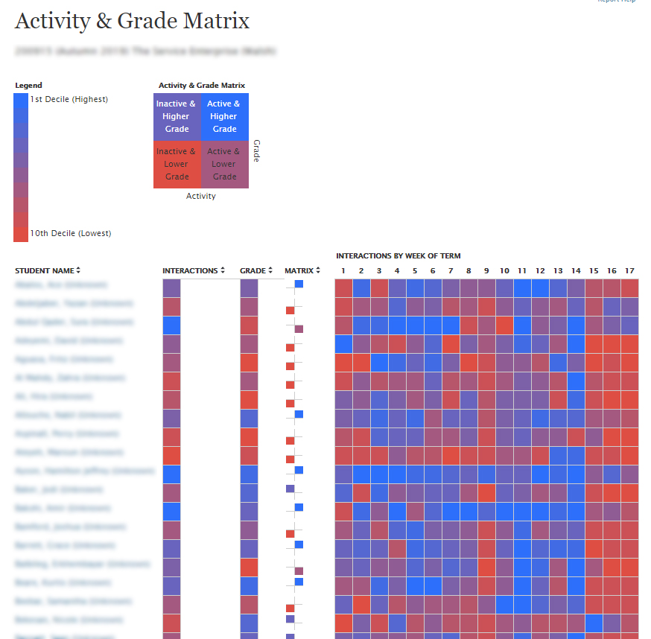

Course Submission Summary Report
This report provides a list of students in a Blackboard Learn unit with submission information for each student.
About this Report
This report can be used to identify students who are not engaged in their units by displaying trends and numbers of submissions compared to the average across all students in that unit. Students below the average may not be sufficiently engaged in the unit and may indicate the need for assistance.
Using the Report
The Learn Unit Information section presents general information about the selected unit.
The Student Activity Summary section shows information about each student and submission activity:
- Student: The name of the student as a link to the Student at a Glance report.
- Enrol Status: The enrolment status of the student from the student information system.
- Submissions Trend: Display of a given student’s submission activity over the entire term.
- Student Submissions: The number of student submissions by Submission Type for the given Blackboard Learn unit.
- Avg: The average number of student submissions for the Submission Type for the given Blackboard Learn unit.
- Date of Last Submission: The actual date of the last submission for the Submission Type for the given Blackboard Learn unit.
- Days Since Last Submission: The number of days since the last submission for Submission Type for the given Blackboard Learn unit.
- Last Submission Type: The last submission type displaying in the report row for that student.
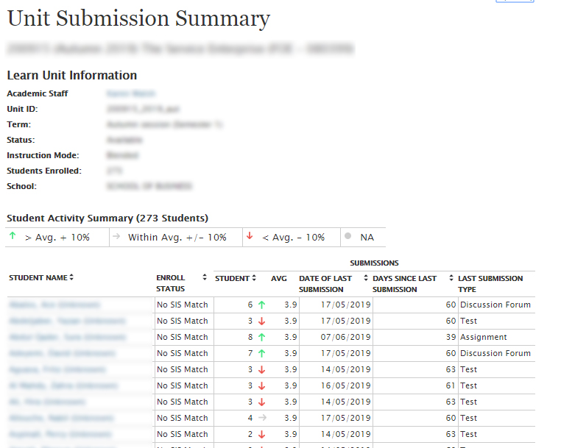

Course Reports
Course reports are run based on a set of parameters such as date range and student number. These reports are useful to see the activity or student interaction of the unit. However, the format for most of the reports may be difficult to collate as it lists each student accesses each day and does not tally over time. For large date ranges this may not be useful.
Reports in the Course Reports section:
All User Activity inside Content Areas | This report displays a summary of all user activity inside Content Areas for the subject.
Overall Summary of User Activity | The report displays user activity for all areas of the subject, as well as activity dates, times and days of the week.
Single Subject User Participation Report | Displays detailed statistics on assessment and collaboration tool submissions for all users in this subject during a specified timeframe.
Student Overview for Single Subject | Student Overview for Single Subject displays an individual student's activity within a subject, sorted by date. Data includes the total overall time the student spent in the subject as well as detailed information about the student's activity, such as which items and Content Areas the student accessed and the time spent on each.
Subject Activity Overview | Subject Activity Overview displays overall activity within a single subject, sorted by student and date. Data includes the total and average time spent per active student and the total amount and type of activity each student had in the subject. Optionally, you can filter the report by one or more groups.
Subject Performance | This report displays information showing how a single Blackboard Learn Subject performs against a selected set of goals. Performance targets and a range of acceptable performance for the subject can be determined when running the report. Data includes averages for the entire subject as well as break downs for individual students and goals.
User Activity in Forums | This report displays a summary of user activity in Discussion Board Forums for the subject.
User Activity in Groups | This report displays a summary of user activity in Groups for the subject.

Information on running a report can be found at https://dft.westernsydney.edu.au/support/#user-activity-report

Performance Dashboard
The Performance Dashboard provides an up-to-date report on the activity for all students. Information appears in a table format. Click a column heading or the caret in the header row of a column to sort the table data by that column.
View-Only Columns
You can sort the data in following columns but you cannot change or review it:
- Last Name
- First Name
- Username
- Role
- Last Course Access
- Days Since Last Course Access
Interactive Columns
When available, you can use the following columns to report on other performance features. Click the link or icon for a user to access his or her data.
- Review Status: Displays the number of content items that have been reviewed by a user. Click the link for a detailed view of content items reviewed.
- Adaptive Release: Click the icon to display the unit map for a user, showing every content item in the unit. Items use icons to indicate whether content items and folders are visible or invisible to a user and whether the items have been reviewed.
- Discussion Board: Displays the number of posts for a user. Click the link to display which forums a user has posted to and statistics about each post. Forum names link to a collection of posts for the user.
- Customise Retention Centre: Displays the number of alerts and the total number of rules for a user. Click the link to open the Retention Centre page for the user.
- View Grades: Click the icon to display the Grade Centre.
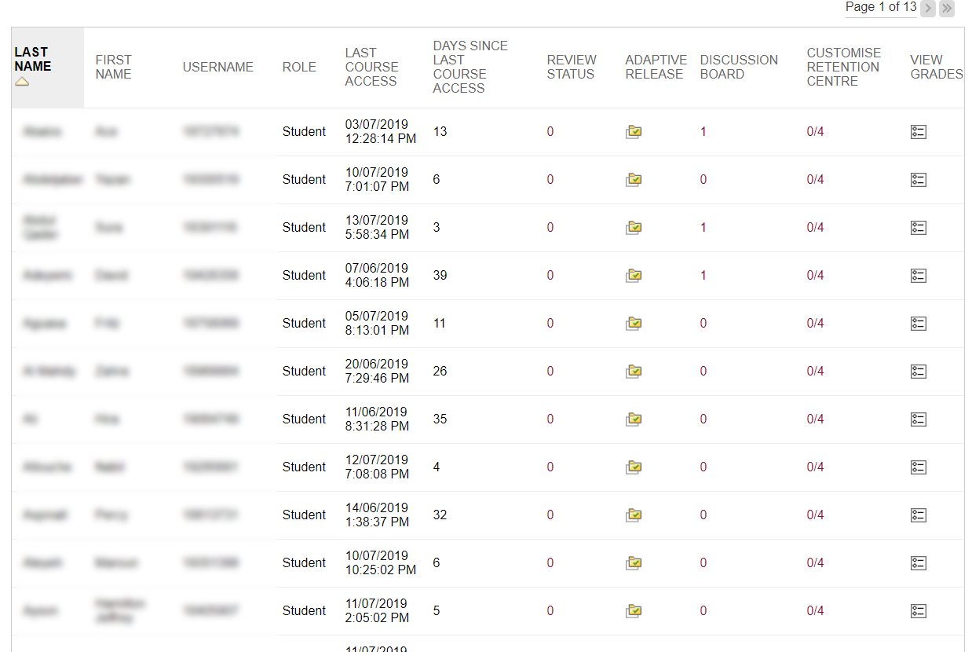

Retention Centre
The Retention Centre provides an easy way for you to discover which students in your unit are at risk. You can communicate with struggling students and help them take immediate action for improvement. You can also keep track of patterns over time.
At Risk Table
The coloured bar preceding the table displays a summary of the at-risk students in your unit.
The main table displays which students are at risk in one or more of the following four categories:
- Missed Deadlines
- Grades
- Course Activity
- Course Access
Most rules' data is refreshed when you access the Retention Centre. However, the data for the unit activity rule is recorded once a day. Your school determines when and how often the data is collected for this rule.
Click the red dot indicator in a student's cell for more information, to include the student in the monitoring section in the right panel, or to send an email. If no students are at risk in any of the rule categories, a smile icon appears in the table with the statement: All your students are doing great!
Click students' names to access their Retention Status pages. View their risk factors and the notification emails you have sent, along with any private notes you have made.
Sort columns by clicking the heading title. The table is sorted by most at-risk students and then alphabetically.
You can create new rules, edit existing rules, and delete rules by clicking Customise on the action bar. You can create as many rules as you need. See https://dft.westernsydney.edu.au/support/#retention-centre-dashboard for help on customising the retention centre.
In the right side panel, you can view two types of information:
- Students you are monitoring: When you click a red dot indicator in the risk table to view information about a student, click the star icon to place the student's information in this panel. You can display a student's card to view his status at all times, or collapse the card until you need to see it.
- Other information you are monitoring: Any rule you exclude from the risk table appears here. If you want to create a rule for activity or participation that does not relate to risk, you can choose to exclude it from the risk table and it will appear here. For example, you can create a rule to display those users doing well in your unit.
Important: All existing Early Warning System rules are retained when your system is updated to include the Retention Centre. These rules appear in the Other information you are monitoring section. You may edit these rules and determine whether or not to include them in your risk table.
Your Unit Activity
The section following the risk table provides a one-stop collection of your activity, engagement, and participation in the unit. You can see:
- How many items need grading.
- How you are engaging your students by posting and commenting in discussions, blogs, and journals.
- The last time you created new content or posted an announcement.
This information is only for you, and other users cannot access it. Each time you enter your unit, you can use it to determine which areas require your attention.
The links in this section allow you to quickly take appropriate action to further engage your students. For example, click an assignment link to begin grading and provide feedback. Easily access your communication tools to interact with your students, or post an announcement.

